BPM Self Commissioning

Description
The BPM self commissioning is a sw tool for automatic identification of BPM main parameters:
- Rs: stator phase resistance (Ohm)
- Ld: stator phase inductance on d-axis (d-axis = rotor flux axis) (H)
- Lq: stator phase inductance on q-axis (H)
- Phim: permanent magnet flux (V/rad/s)
- KTorque: the torque constant due to the permanent magnet (1.5*p*Phim)
- KDeflux: the torque constant due to the reluctance (1.5*p*(Ld-Lq))
The BPM self commissioning test is composed by three phases:
- High frequency voltage injection Ld/Lq identification
- Dc voltage injection Rs identification
- Bemf Observer speed close loop control Phim, Ktorque, Kdeflux identifications

HW Requirements
The communication with the board is performed through the microcontroller UART channel.
- A TTL – RS232 USB optoisolated converter is needed in order to connect the board to the PC running the Self Commissioning SW.

SW Requirements
The autotesting is based on the following standard components:
- Python interpreter (3.6) use the following guide to install Python: https://drive.google.com/open?id=1v-bfxefjiZIwiWRHGzR3U37f-EHdH-PMDYxP2-8Lhqo
- RTC, it is used as repository and version control.

and the following custom components:
- Dwarf_Parser: it is used to parse and handle elf files (used for the PIL approach)
- Master_Commander: it is used to manage communication between PC and the microcontroller using a light protocol (PIL approach)

Setup for custom Fw
- Load “SELF_COMMISSIONING” component in your fw from RTC: _Debug_Testing_Lib stream in “Motor Control” Change Management
  - Load the Docs folder in Project structure docs folder:
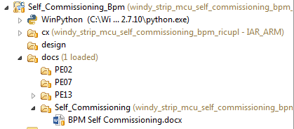
  - Load the Source folder in Project structure source/Category/Common:
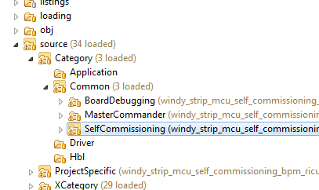

- Place the SelfCommissioning handlers in MCI callbacks (Mci_prm.h + Mci_prv.h)
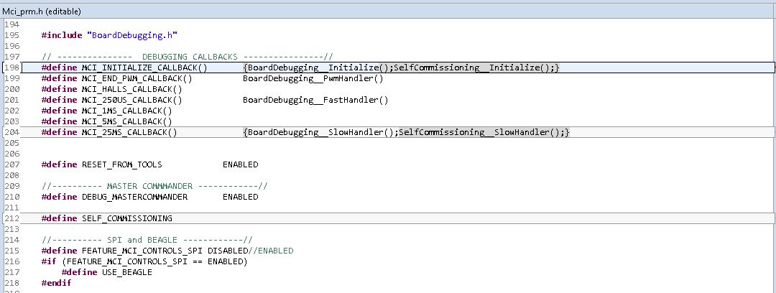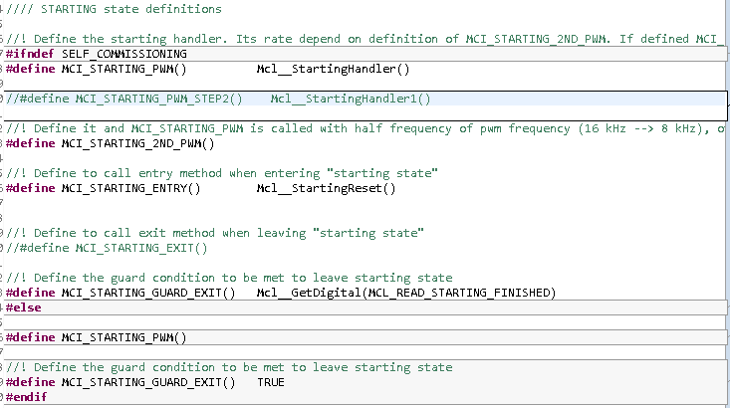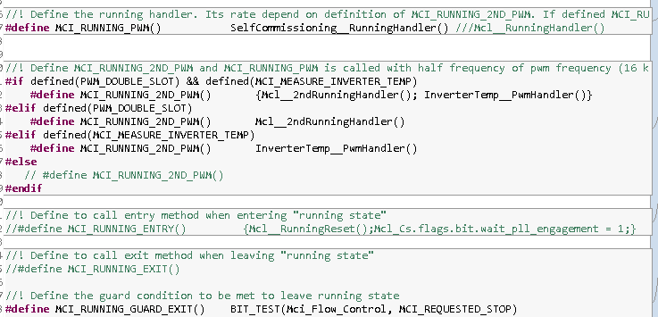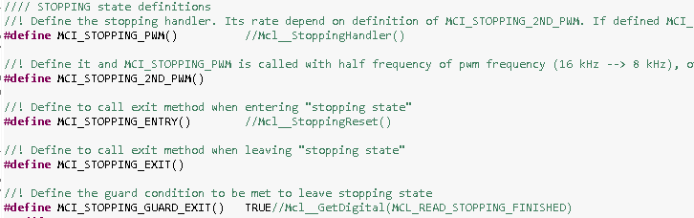

- Modifiy Motor parameters inside SelfCommissioning.c file- “Parameter_Initialize()”
  - Change motor pole pairs parameter according your application
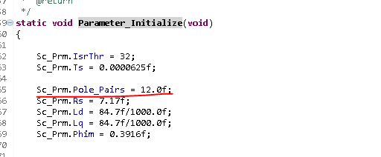

- Compile and download your code.

Setup Python for custom Fw
- Load the Python directory from “SELF_COMMISSIONING” component in the <workspace_root>/self_commissioning location;
- From the PYTHON_COMMUNICATION_LIB component load the master_commander folder in the Project <workspace_root>/self_commissioning/master_commander location;
- From the PYTHON_UTILITIES_LIB component load the dwarf_parser folder in the Project <workspace_root>/self_commissioning/dwarf_parser location;
- In the self_commissioning folder you should find a sample configuration file with cfg extension. Modify it according to your needs, following the comments in the file itself;
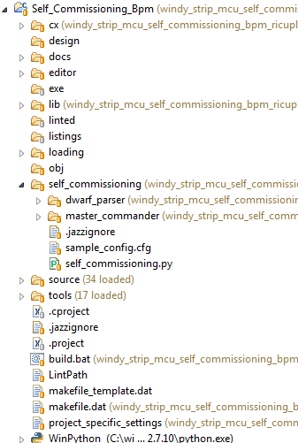

- Configure the COM parameters;
- Configure file paths parameters;
- Configure the measurements sections according to your application;
- Go to Run Run Configurations and double click on Python Run;
- In the Dialog Window, select the current Project clicking the Browse button;
- Select the self_commissioning.py file as the Main Module;
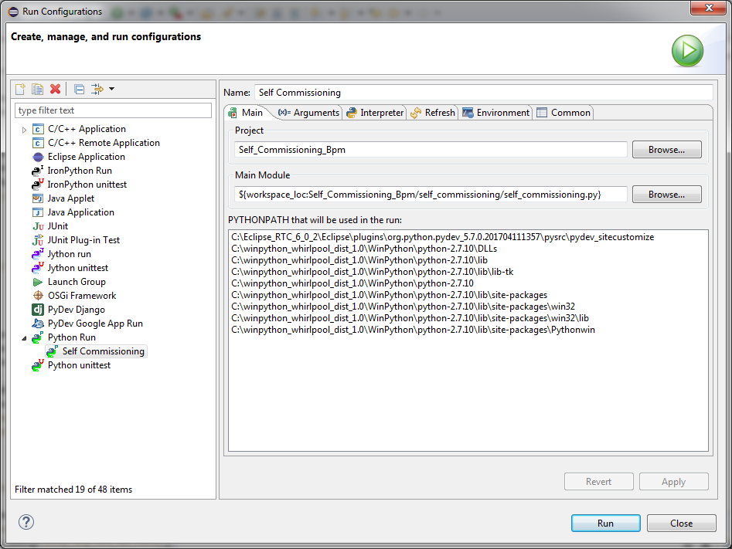

- Select the Arguments tab. Choose other as the Working directory and browse the Workspace to select the self_commissioning directory;
- Provide the path to the configuration file in the Program arguments. If the file is in the same directory of the script (self_commissioning), just type ./name_of_config_file.cfg in there

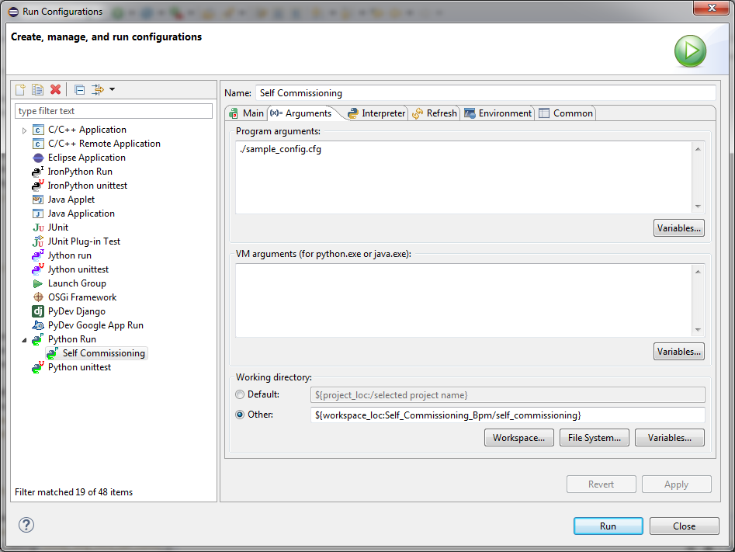

- Click on the Apply button and then Run to launch the script.
- At the end of the procedure you should find the report in the self_commissioning/out folder.



- Click on the Apply button and then Run to launch the script.
- At the end of the procedure you should find the report in the self_commissioning/out folder.

